Use case diagram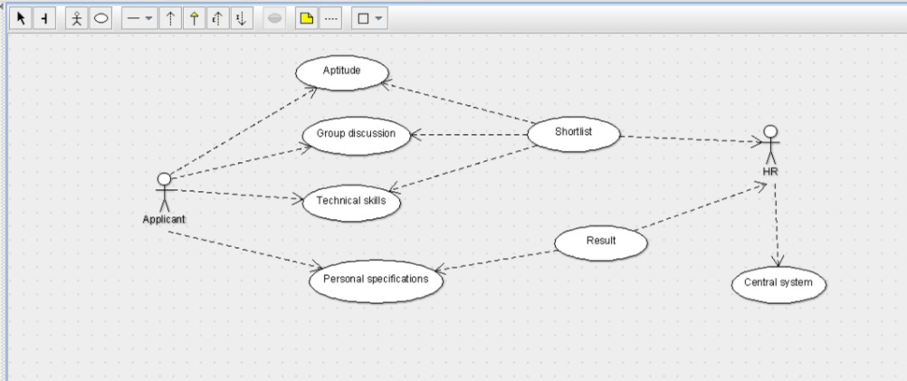

Class diagram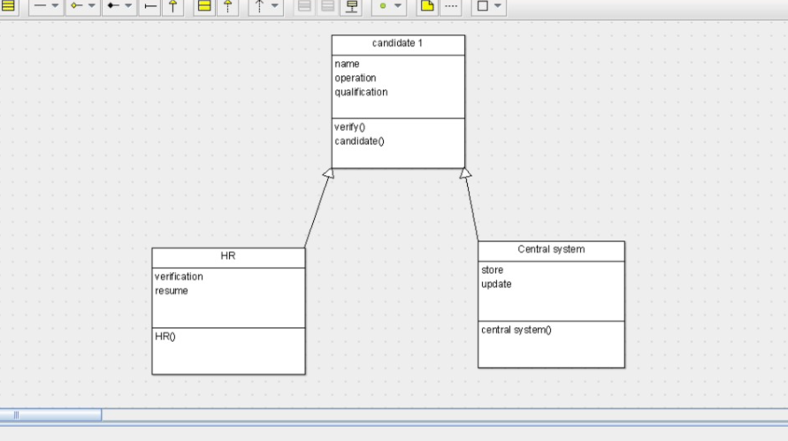

public class Central system extends candidate 1 {

public store;

public update;

public void central system() {

}

}public class candidate 1 {

public name;

public operation;

public qualification;

public void verify() {

}

public void candidate() {

}

}

SEQUENCE DIAGRAM

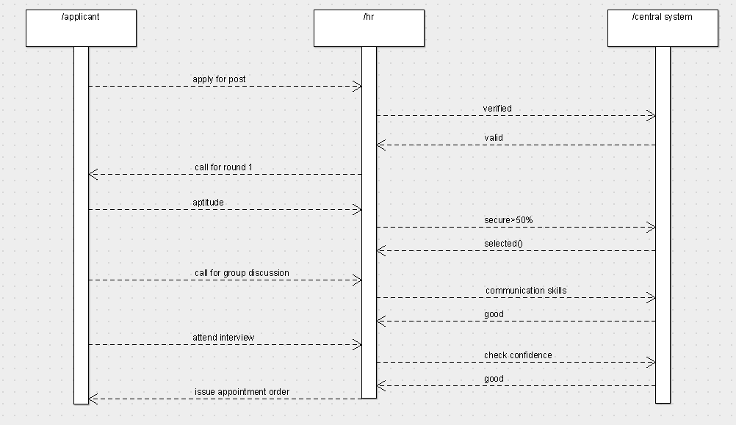

COLLABORATION DIAGRAM

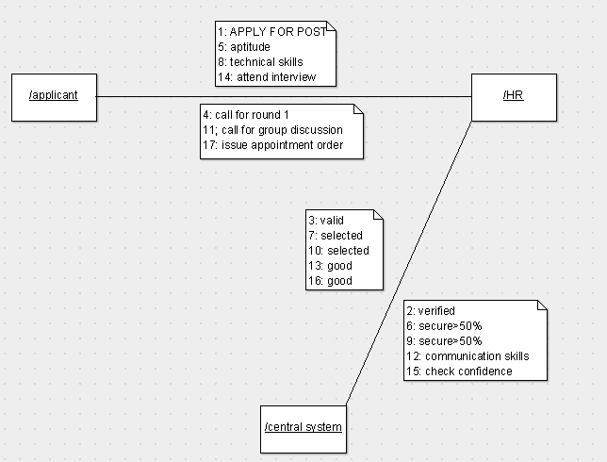

Activity diagram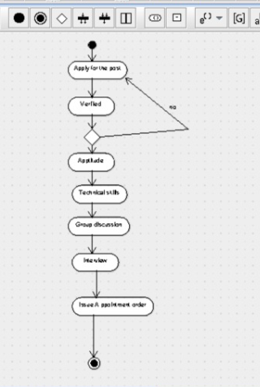public class HR extends candidate 1 {

public verification;

public resume;

public void HR() {

}

}

STATE CHART DIAGRAM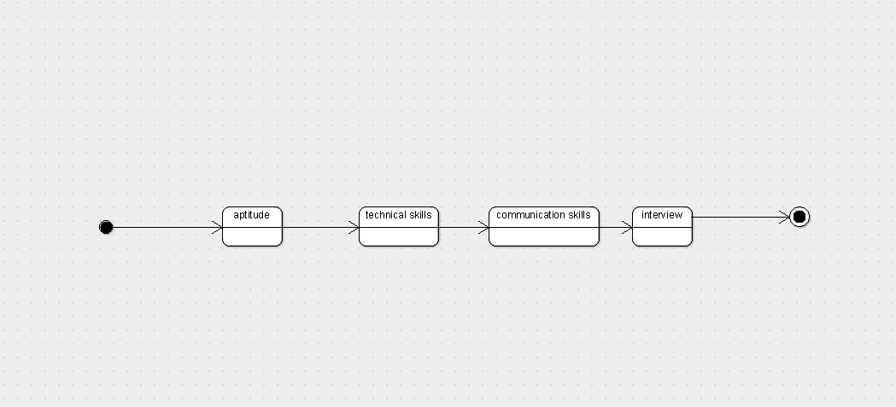

COMPONENT DIAGRAM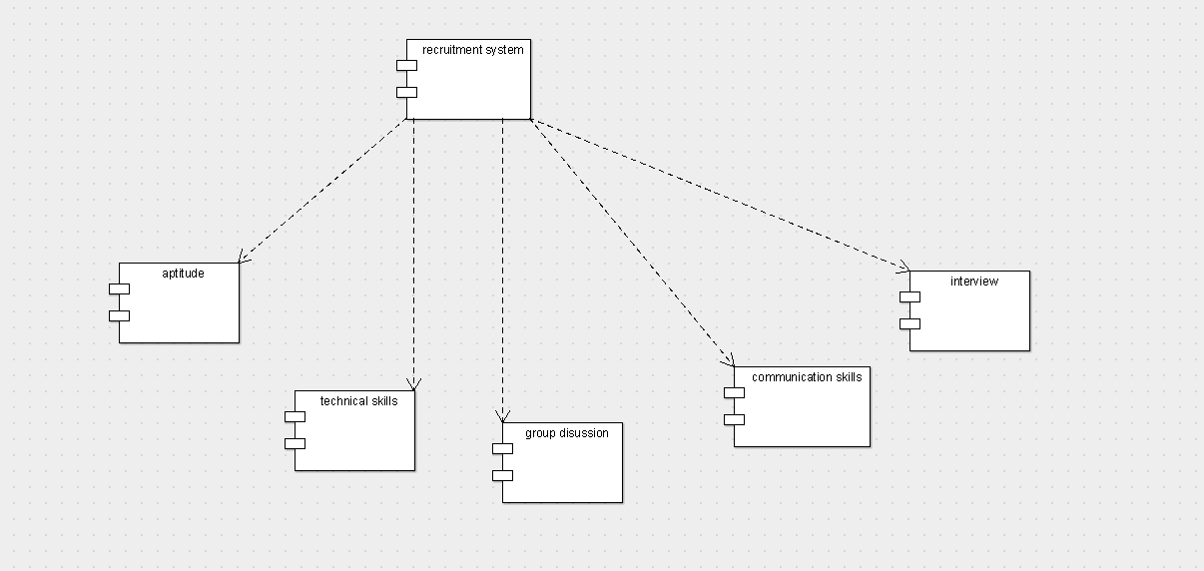

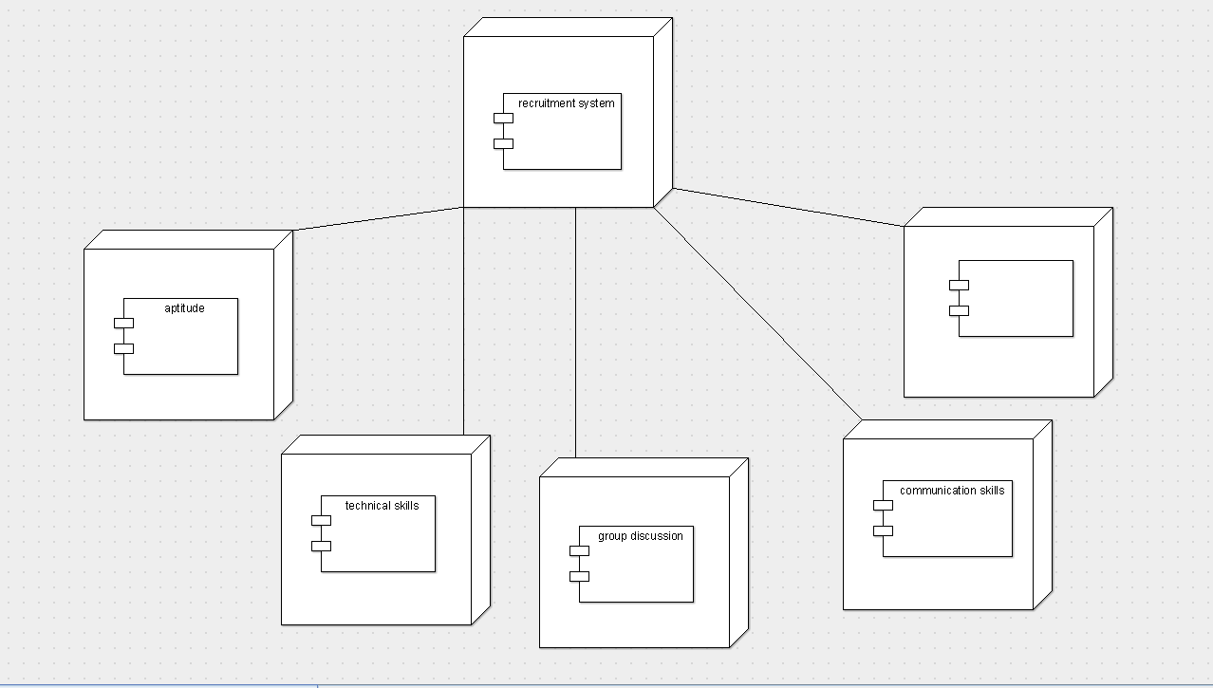DIPLOYMENT DIAGRAM